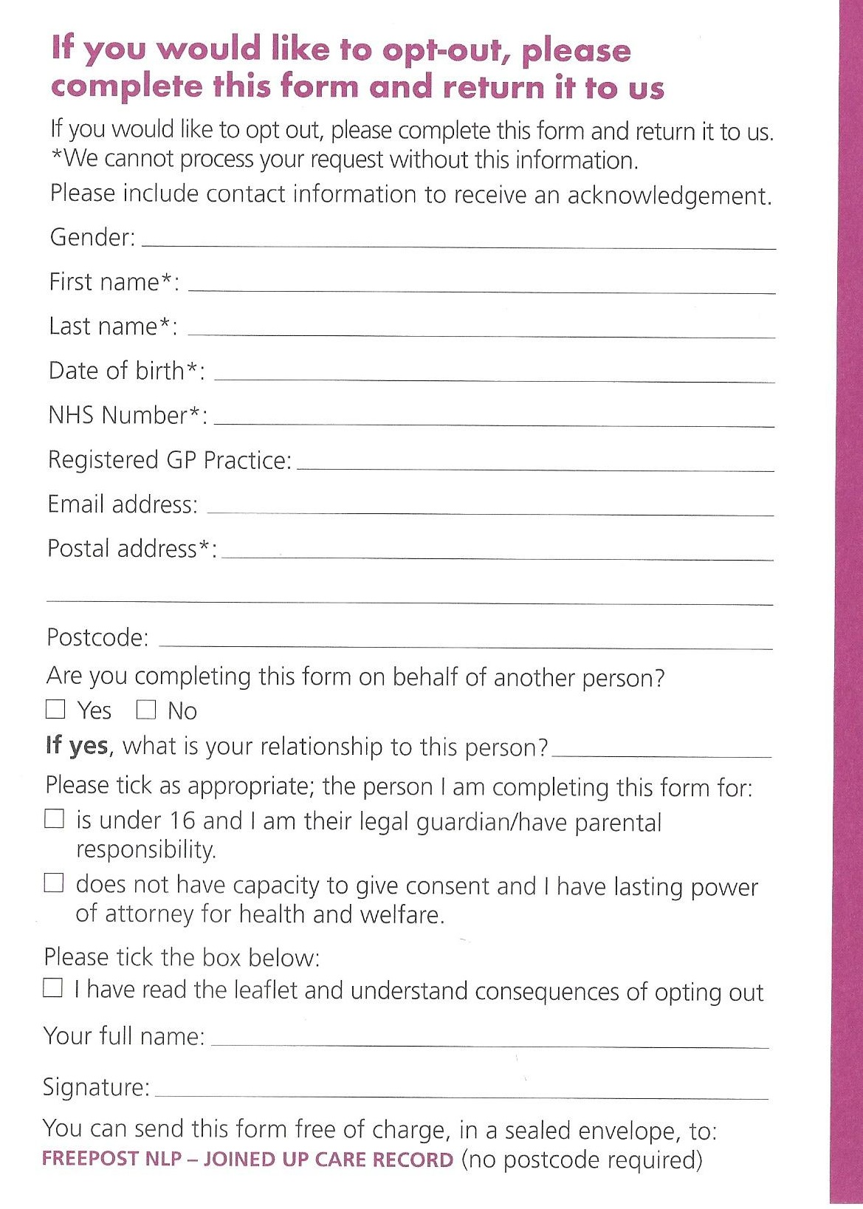
Please note: This is not an online form. You must send it by post (free of charge).

Alexandra Surgery, 125 Alexandra Park Road, London N22 7UN

